TASK # 01



Spring 2024
CSE-307L Microprocessor Based System Design Lab

Submitted by: Ali Asghar
Registration No.: 21PWCSE2059
Class Section: C

“On my honor, as student of University of Engineering and Technology, I have neither given nor received unauthorized assistance on this academic work.”

Submitted to:
Dr. Asif Ali Khan

Date:
25th February 2024

Department of Computer Systems Engineering
University of Engineering and Technology, Peshawar

Tasks:
Write assembly language code to
a) Create a delay of 10msec
b) Turn ON an LED for 8msec and then turn OFF for 4msec. Do it continuously.
Part a:
Code:
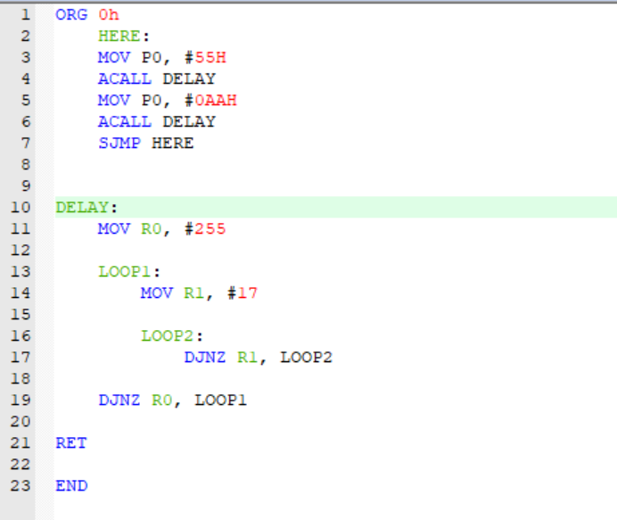
1 MC
1 MC x 255
2 MC x 255 x 17
2 MC x 255
2 MC

Calculations:
Total Machine Cycles = 1 MC + (1 MC x 255) + (2 MC x 255 x 17) + (2 MC x 255) + 2 MC = 9438 MC
Delay = 9438 x 1.085µs = 10ms

Proteus Simulation:
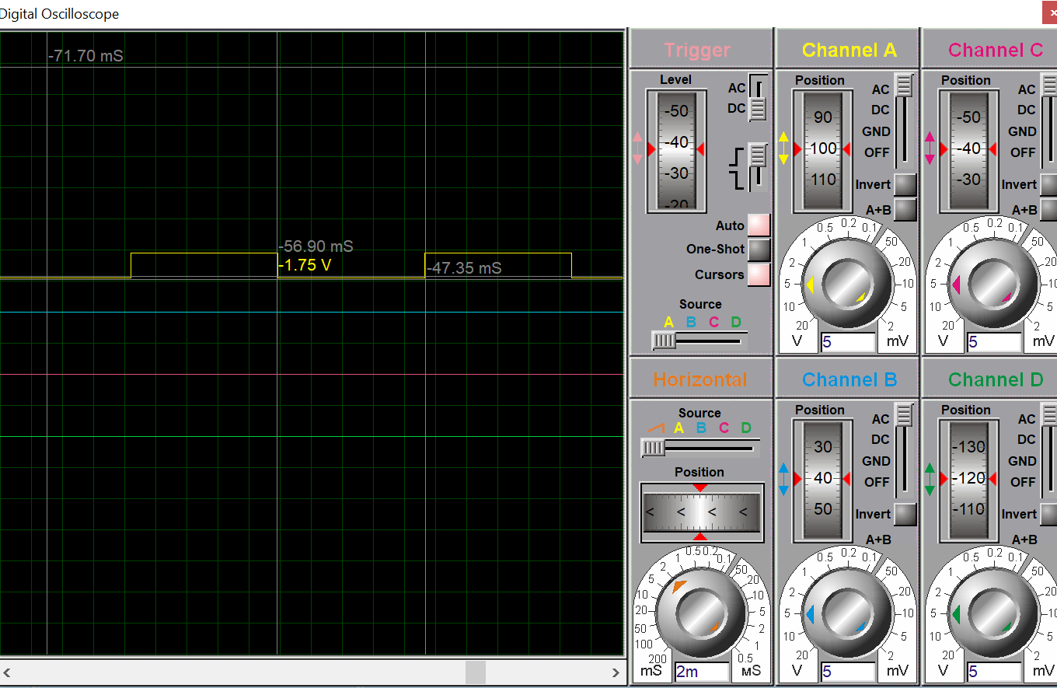

Part b:
Code:
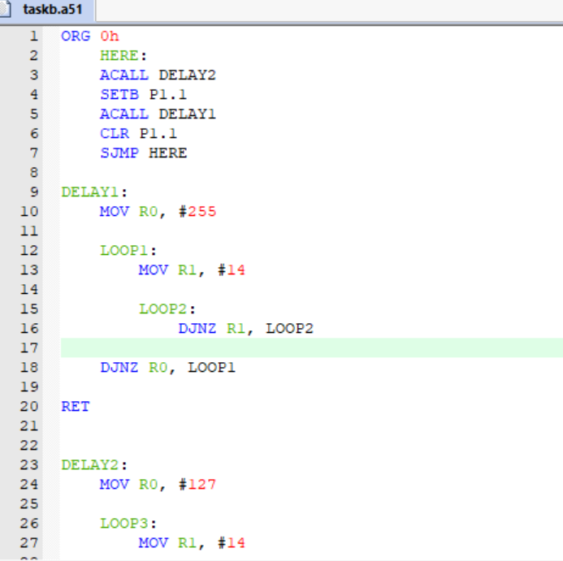
1 MC
1 MC x 255
2 MC x 255 x 14
2 MC x 255
2 MC
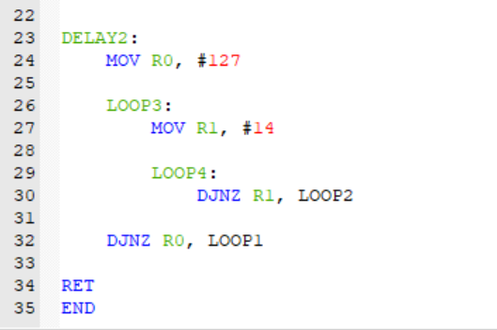
1 MC
1 MC x 127
2 MC x 127 x 14
2 MC x 127
2 MC

Calculations:
Delay1:
Total Machine Cycles = 1 MC + (1 MC x 255) + (2 MC x 255 x 14) + (2 MC x 255) + 2 MC = 7908 MC
Delay = 7908 x 1.085µs = 8ms

Delay2:
Total Machine Cycles = 1 MC + (1 MC x 255) + (2 MC x 127 x 14) + (2 MC x 255) + 2 MC = 4324 MC
Delay = 4324 x 1.085µs = 4ms

Output:
